What is Angular Universal?
In general, Angular Universal is a Pre-Rendering solution for Angular. This is a node-based angular rendering engine

To understand what this means, let's remember that in a normal single page application, we usually bring the data to the client and then build the HTML that represents that data last second on the client side.
But in certain situations and by good reasons, we might want to instead do that rendering ahead of time, for example on the server or at application build time: and that is exactly what Angular Universal allows us to do.

How does Angular Universal work?
- Using Angular Universal, we render ahead of time some HTML and CSS and show it to user, so the user can see something on the screen quickly.
- Along with the HTML rendered on the server side, we will also send a normal Angular client application to the browser.
- This Angular client application will then take over the page, and from there on everything is working like a normal single page application, meaning that all the runtime rendering will occur directly on the client as usual.

There are two main important reasons to create a Universal version of your app.
- Facilitate web crawlers through search engine optimization espatially for social media crowlers.
If we open some SEO-optimized page, for example https://blog.angular.io/ivys-internal-data-structures-f410509c7480,
we can see quite many different meta tags:
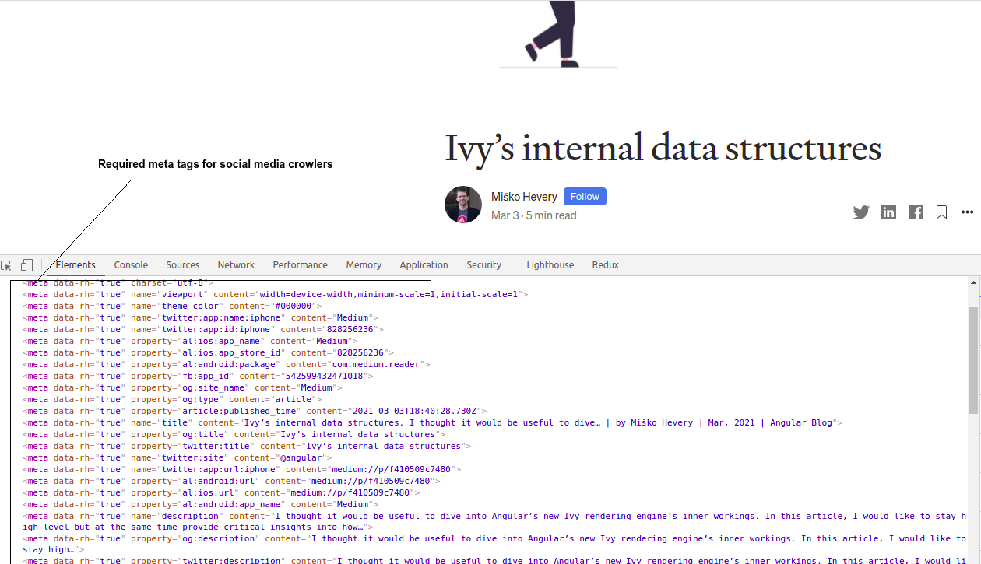
These meta tags give to crowler all necessary information about title, description and content the information, what we can share via this social network, for example. But without any server side rendering social media crowlers can`t process this page because all of the html will be calculated at runtime.
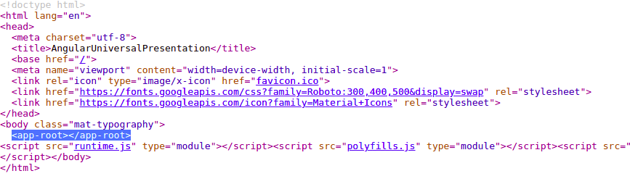
*And it of couse makes sense if application is reachable from the internet at least for pages that don`t need authentication.
*Modern search engines like Google can already indexing SPA that don`t have any content served on the initial request. For example if we type in Google some string from the Angular documentation page «Angular Universal can generate a static version of your app that is easily searchable, linkable, and navigable without JavaScript.» we gat the exact result:
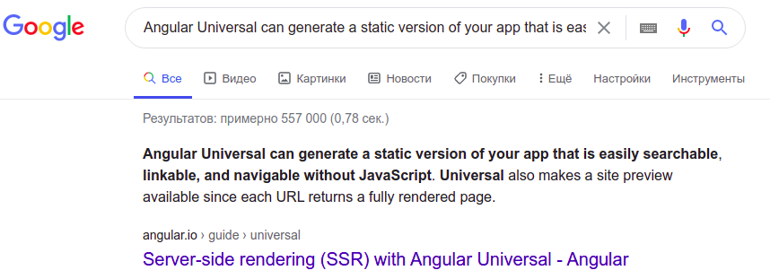
despite the fact that in this case no any SSR. The Google search engine knows how to wait for the all js is loaded, ajax requests are complete and page is ready to analizing.
- Angular Universal can generate a static version of app that is easily searchable, linkable, and navigable without JavaScript. Universal also makes a site preview available since each URL returns a fully rendered page.
- The second main reason for using Angular Universal now is the user experience and startup performance in app-s running on mobile devices with slow internet. Show the first page quickly with a first-contentful paint (FCP)
Displaying the first page quickly can be critical for user engagement.
In practice, you'll serve a static version of the landing page to hold the user's attention. At the same time, you'll load the full Angular app behind it.
As we know, a single page when initially loaded is essentially an empty index.html file with almost no HTML. This means that when this HTML file gets initially rendered by the browser, all that the user will see is a completely blank screen!
Depending on the application loading time can take several seconds

Statistics: 53% of all users leave an application if it takes longer than 3 seconds to load!

Thats why this initial delay in showing something to the user is critically important.

Simple SPA performance picture: https://drive.google.com/file/d/1o1jLqnOXbueSXhZJk3n0sPO1xcjCCMNq/view?usp=sharing
SPA with Angular Universal performance:
https://drive.google.com/file/d/1NtsXeBE9Be-0Iv5ZEas9GpI51ofFsO_r/view?usp=sharing

How to add Angular Universal to app?
It is very easy - ng add @nguniversal/express-engine
this command creates couple of specific scripts:

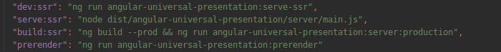
build:ssr — build app for the production and build server part as well.
serve:ssr — enables serve the production version
prerender — enables to prerender the app at build time
dev:ssr — to run development version in hot reload mode

SEO optimization:

Let`s type in Google some search query, for example «angular universal»
we get many results :
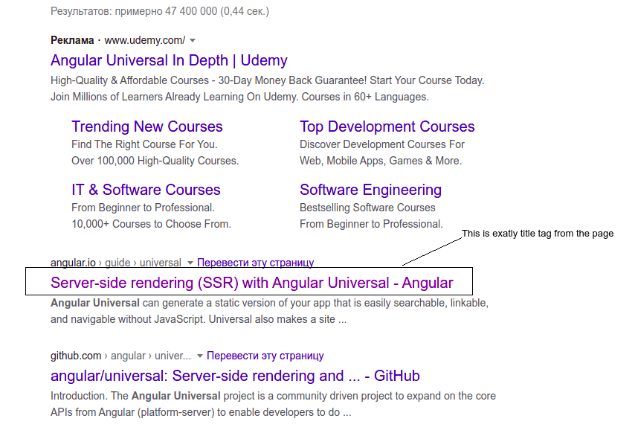
if we open page https://angular.io/guide/universal we can confirm that google shows us content from the title tag as a title of search result
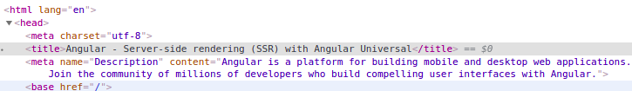

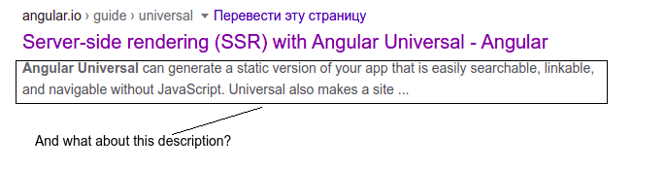

Description will depend on the search query, but we can set default text:
If search engine can`t determine any description that is dependent on the query that we made, then it will use this default text from the metatag.
Title and description should depend on the page that we are seeng.
*Google search engine can read dinamic values of metatags (if that values are set in runtime by js). But it is not a case for many other search engines.In case of Angular Universal app we get each page with actual metatags from the backend on the very initial request. This makes the application responsive to all search engines.

Performance:
Sometimes the page is large, but the main goal of SSR is to show something to the user as soon as possible. This case we want to be able to render all metatags and the title and at leas some initial html to the device, containing only some general part and information — this is called Initial Shell of the page. In order to inform the Angular Universal of which parts we want to server side render, we should create an Auxiliary directive.

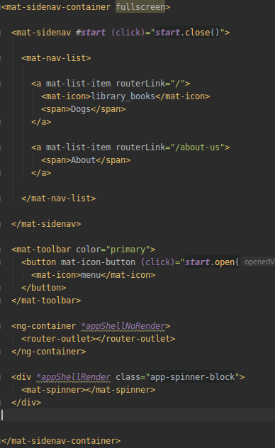

*appShellNoRender means that this part of our app should not be rendered on the server side

*appShellRender — this part should be rendered on server side

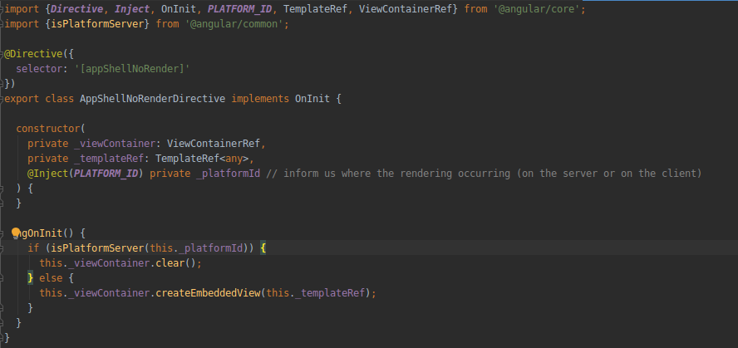

But if we apply *appShellNoRender to the router outlet, any routes won`t be rendered and we won`t get any metatags and the title on particular routes, that`s why it`s better to render the router-outlet, but apply this directive to the template of component to avoid of ssr it`s html, but only metatags, title and may be some parts of the page

